 | Dissertation Title: | Developing an AI powered Data Protection Officer
 | Surname: | Siwakoti
 | First Name: | Khusi
 | Student Number: | 19387308
 | Supervisor: | Dr. Manny Niri
 | Dissertation Module: | COMP7039
 | Course Title: | Dissertation in Computing Subjects
 | Date Submitted: | 25th September, 2026
MASTER OF SCIENCE DISSERTATION
FINAL REPORT
Statement of Originality

Except for those parts in which it is explicitly stated to the contrary, this project is my own work. It has not been submitted for any degree at this or any other academic or professional institution.

Signature of Author | Khusi Siwakoti | Date | 25th September 2026

Regulations Governing the Deposit and Use of Master of Science Dissertations in the School of Engineering, Computing and Mathematics, Oxford Brookes
University.

- A copy of dissertation final reports submitted in fulfilment of Master of Science course requirements shall normally be kept by the School.

- The author shall sign a declaration agreeing that, at the supervisor’s discretion, the dissertation will be submitted in electronic form to any plagiarism checking service or tool.

- The author shall sign a declaration agreeing that the dissertation be available for reading and copying in any form at the discretion of either the dissertation supervisor or in their absence the Programme Lead of Postgraduate Programmes, in accordance with 5 below.

- The project supervisor shall safeguard the interests of the author by requiring persons who consult the dissertation to sign a declaration acknowledging the author's copyright.

- Permission for anyone other than the author to reproduce in any form or photocopy any part of the dissertation must be obtained from the project supervisor, or in their absence the Programme Lead of Postgraduate Programmes, who will give his/her permission for such reproduction only to the extent to which he/she considers to be fair and reasonable.

I agree that this dissertation may be submitted in electronic form to any plagiarism checking service or tool at the discretion of my project supervisor in accordance with regulation 2 above.

I agree that this dissertation may be available for reading and photocopying at the discretion of my project supervisor or the Programme Lead of Postgraduate Programmes in accordance with regulation 5 above.

Signature of Author | Khusi Siwakoti | Date | 25th September 2026

Table of Contents
1. Introduction 1
1.1. Background 1
1.2. Aim 1
1.3. Objectives 1
1.4. Product Overview 2
2. Background Review 3
2.1. Web Application Security Threats 3
2.2. DPO Role and GDPR 3
2.3. Existing Monitoring and Compliance Tools 4
2.4. AI in cybersecurity 5
2.5. Research Gap and Contribution 5
3. Methodology 6
3.1. Research and Development Approach 6
3.2. System Architecture 6
3.3. Technology Stack 7
4. Results 8
4.1. System Implementation 8
4.2. Testing and Evaluation 8
4.3. Project Management 8
4.4. Risk Analysis 8
4.5. Professional Issues 8
5. Conclusion 9
5.1 Summary of Achievements 9
5.2 Future Work 9
5.3 Personal Reflection 9
6. References 10
7. Appendix 11

Table of Figures

Figure 1: System Architecture 8
Figure 2: Gantt Chart 12

Table of Tables

Table 1: Tools and technology used 9
Table 2: Risk Analysis 10

List of Abbreviations

Abbreviation | Full Form
AI | Artificial Intelligence
BCS | The chartered Institute for IT (formerly British Computer Society)
DPO | Data Protection Officer
CRUD | Create, Read, Update, Delete
GDPR | General Data Protection Regulation
HTML | Hypertext Markup Language
IDS | Intrusion Detection System
API | Application Programming Interface
DPIA | Data Protection Impact Assessment
OWASP | Open Web Application Security Project
PDF | Portable Document Format
SIEM | Security Information and Event Management
SME | Small and Medium sized Enterprise
SQL | Structured Query Language
SQLite | Lightweight Embedded SQL Database Engine
URL | Uniform Resource Locator
XSS | Cross site scripting
UI | User Interface
SAR | Subject Access Request
ROPA | Record of Processing Activities
ICO | Information Commissioner's Office
CSS | Cascading Style Sheets

Abstract

This report presents the design and development of an AI powered Data Protection Officer (DPO) system. A web based application that enables users to perform the core responsibilities of a DPO through a guided, interactive environment. The system addresses a documented gap in the market: small and medium sized organisations that are legally required to comply with GDPR but lack the resources for enterprise security tools or dedicated data protection personnel. By using Python, Flask, SQLite and the Anthropic claude API, the system provides seven structured tasks covering data mapping, compliance assessment, risk evaluation, data request handling, real time threat monitoring, policy management and staff training. A rule based detection engine scans user inputs across the application for five types of web application attacks, with AI providing automatic incident classification and severity assessment. The system generates GDPR compliance breach reports in PDF format and includes cross task AI intelligence that analyses data from all completed tasks to identify risks not visible when tasks are considered individually. Testing through simulated attack scenarios demonstrated effective detection of common web application threats, while AI classification provided contextual, actionable recommendations. The project contributes a practical demonstration of how artificial intelligence can be integrated into data protection workflows to make regulatory compliance more accessible for organisations with limited cybersecurity resources.

Acknowledgements

I would like to express my gratitude to my supervisor Dr. Manny Niri, for his consistent guidance, feedback and support throughout this project. His advice on expanding the system beyond basic breach detection to cover the full scope of DPO responsibilities significantly improved the quality and depth of this project.

I would also like to thank Oxford Brookes University and the School of Engineering, Computing and Mathematics for providing the resources and academic framework that made this dissertation possible.

Finally, I would like to thank my family and friends for their encouragement and patience throughout the course of this project.

Introduction

Background
The volume of personal data processed by web applications has grown substantially over the past decade. Organisations of all sizes now rely on online platforms for customer transactions, internal communications and data storage, making web applications an increasingly attractive target for cyber attackers. Common threats such as phishing, brute force login attempts, SQL injection and cross site scripting continue to cause significant damage, largely because many web applications still contain fundamental security weaknesses that remain unaddressed

Aim

Objectives

Product Overview

Background Review

Web Application Security Threats
Web applications are one of the most commonly attacked components in any organisation’s infrastructure. The (OWASP , 2021) Top Ten lists broken access control as the number one risk, followed by cryptographic failures and injection attacks. What is notable is that these are not sophisticated threats, they exploit basic implementation mistakes that keep recurring across the industry.
Phishing is particularly effective against web application users. (Gupta, et al., 2016) reviewed the state of phishing detection research and found that phishing works mainly because it targets human judgement rather than technical defences. This is relevant for the proposed system because it means detection needs to look at what users are submitting (suspicious URLs, unusual form inputs) rather than just network packets.

Brute force attacks against login pages remain common. (Florencio & Herley, 2007) studied password habits at scale and found widespread credentials reuse, which means one breached password can unlock multiple accounts. Monitoring failed login attempts is therefore a straightforward but valuable detection strategy and it forms one of the core capabilities of the proposed system.

DPO Role and GDPR
GDPR Articles 33 sets out what must happen when a breach is discovered; the organisation must notify its supervisory authority within 72 hours, describing the nature of the breach. And the categories and approximate number of people affected, the likely consequences and the steps taken to address it (European Union, 2016). Article 34 adds that individuals must be notified directly if the breach poses a high risk to their rights.

Articles 37 to 39 establish the DPO role. A DPO must advise the organisation on its data protection obligations, monitor internal compliance, provide guidance on data protection impact assessments and serve as point of contact for regulators. (Voigt & Von dem Bussche, 2017) note that GDPR moved data protection from a back-office concern to board level responsibility requiring organisations to prove they are compliant rather than simply claiming it.

The practical difficulty is that hiring a qualified DPO is expensive. (ENISA, 2021) reported that many SMEs across Europe do not have anyone in a dedicated data protection role. This project directly addresses that problem by automating the monitoring, classification and reporting tasks that a DPO would normally handle.

Existing Monitoring and Compliance Tools
There are different approaches and system developed for monitoring and reporting breaches. Likewise, (Scarfone & Mell, 2007) offer a useful classification for intrusion detection systems. Signature based technologies, such as Snort match events against known patterns and are effective for identified threats but they overlook emerging threats. Anomaly based systems can detect fresh assaults by highlighting unexpected behaviour, but they frequently create false signals. In fact, most organisations require a blend of two techniques.

Enterprise SIEM technology such as Splunk and IBM QRadar collect data from many sources and correlate events across a whole infrastructure. However, they are costly to license, need specialized technology and require qualified analysts to operate. (Bhatt, et al., 2014) discovered that even businesses with SIEM systems frequently experience alert fatigue due to the device’s high volume of notifications.

On the open-source side, OSSEC provides host-based detection, while security onion provides network monitoring. These are less expensive but neither contains GDPR compliant reporting and both needs significant configuration effort. Crucially, none of these commercial or open-source methods integrate web application threat detection with automated DPO style compliance reporting. That is the gap that this report and system aims to bridge.

AI in cybersecurity

Research Gap and Contribution
Looking across the literature, research on intrusion detection and research on GDPR compliance tend to exist in separate silos. (Buczak & Guven, 2016) surveyed machine learning methods for intrusion detection but did not consider compliance reporting. (Voigt & Von dem Bussche, 2017) provided detailed GDPR guidance but from a purely legal perspective without addressing technical monitoring. (Sommestad, et al., 2014) built sophisticated security modelling tools but their approach requires enterprise level expertise.

What is missing is a useful tool that brings these together: detecting web application threats, classifying them with AI and then automatically producing the documentation that GDPR requires. This project aims to fill exactly that gap and the focus on web application specifically makes it directly relevant to the kinds of systems that smaller organisations actually run.

Methodology

Research and Development Approach
The project follows a design science research approach as described by (Hevner, et al., 2004) which involves building an IT artifact and then evaluating it against defined criteria. For the software development process, the project uses Agile with iterative sprints. Each sprint produces a working increment of the system that can be tested and refined before moving on. This is a good fit for a security project because detection rules often need adjustment based on what the testing reveals.

System Architecture
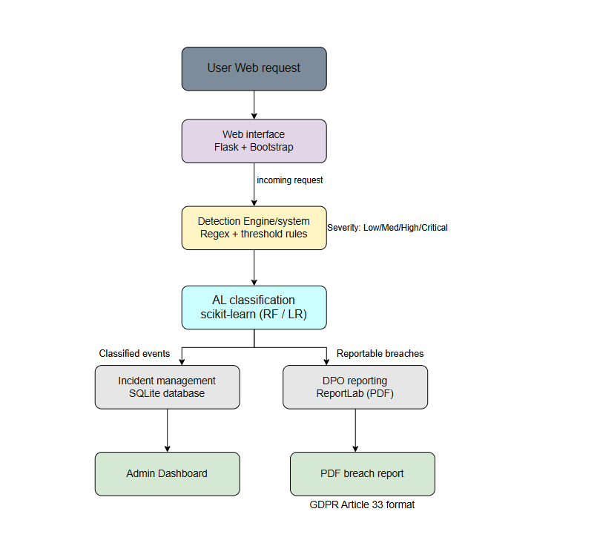
Figure 1: System Architecture
Draw.io platform was utilized for creating the system architecture diagram.

The system consists of five key elements that function together.
- Web Interface (Flask and Bootstrap) – This acts as both the simulated web application that users interact with and admin dashboard that displays security events. It manages login pages, form submissions and real time alert displays.
- Detection System (Python Regex and Threshold Logic) – This lies behind the web application, scanning each incoming request for suspicious patterns. It looks for several unsuccessful logins, recognized phishing URL structure and common injection strings in form fields.
- AI Classification module (scikit-learn) – When the detection system detects something this element takes control. It sends the event to a trained machine learning model (Random Forest or Logistic Regression). This then, assigns a severity level and decides if the occurrence is likely reportable under GDPR Article 33.
- Incident Management module (SQLite) – The logs every detected event with date and time, source identity, threat category and severity ratings assigned by AI. This generates the audit trial that GDPR demands.
- DPO reporting module (ReportLab) – This module extracts data from event database and provides structured PDF breach reports in Article 33 format. The details include what happened, who was affected, what the implications were and what is being done about it.

Technology Stack
Component | Technology/Tool | Justification
Programming Language | Python | Extensive security libraries; readability
Web Framework | Flask | Lightweight; suited to prototyping
Database | SQLite | Embedded; Zero configuration
Frontend | HTML/CSS/Bootstrap | Responsive; rapid environment
Detection Logic | Regular Expressions / Threshold Rules | Transparent; auditable; low overhead
AI Classification | Scikit learn | Standard ML library; interpretable models
Reporting | ReportLab | PDF output for formal breach reports
Testing Tools | Pytest / Requests | Automated unit & integration testing
Version Control | GitHub | Industry standard; audit trail
Table 1: Tools and technology use

Results

System Implementation

Testing and Evaluation

Project Management

Risk Analysis

Professional Issues

Conclusion

5.1 Summary of Achievements

5.2 Future Work

5.3 Personal Reflection

References
Bhatt, S., Manadhata, P. & Zomlot, L., 2014. The operational role of security information and event management systems. IEEE Security and Privacy, 12(5), pp. 35-41.
Buczak, A. & Guven, E., 2016. A survey of data mining and machine learning methods for cyber security intrusion detection. IEEE Communications Surveys and Tutorials, 18(2), pp. 1153-1176.
ENISA, 2021. ENISA Report - Cybersecurity for SMES Challenges and Recommendation. [Online]
Available at: https://www.enisa.europa.eu/sites/default/files/publications/ENISA%20Report%20-%20Cybersecurity%20for%20SMES%20Challenges%20and%20Recommendations.pdf
[Accessed 23 May 2026].
European Union, 2016. REGULATION (EU) 2016/679 OF THE EUROPEAN PARLIAMENT AND OF THE COUNCIL. Official Journal of the European Union, Volume L 119, pp. 1-88.
Florencio, D. & Herley, C., 2007. A large-scale study of web password habits. Proceedings of the 16th International Conference on World Wide Web, pp. 657-666.
Gupta, B., Tewari, A., Jain, A. & Agrawal, D., 2016. Fighting against phishing attacks: state of the art and future challenges. Neural Computing and Applications, 28(12), pp. 3629-3645.
Hevner, A., March, S., Park, J. & Ram, S., 2004. Design science in information systems research. MIS Quarterly, 28(1), pp. 75-105.
IBM, 2024. Cost of a Data Breach Report 2024. [Online]
Available at: https://www.ibm.com/reports/data-breach
[Accessed 23 May 2026].
OWASP , 2021. OWASP Top 10:2021. [Online]
Available at: https://owasp.org/Top10/2021/
[Accessed 22 May 2026].
Scarfone, K. & Mell, P., 2007. Guide to Intrusion Detection and Prevention Systems (IDPS), Gaithersburg: National Institute of Standards and Technology (NIST).
Sommestad, T., Holm, H. & Ekstedt, M., 2014. The Cyber Security Modeling Language: A Tool for Assessing the Vulnerability of Enterprise System Architectures. IEEE Systems Journal, 7(3), pp. 363-373.
Stallings, W., 2018. Effective Cybersecurity: A Guide to Using Best Practices and Standards. Boston: Addison-Wesley.
Verizon, 2026. 2026 Data Breach Investigations Report. [Online]
Available at: https://www.verizon.com/business/resources/reports/dbir/
[Accessed 22 May 2026].
Voigt, P. & Von dem Bussche, A., 2017. The EU General Data Protection Regulation (GDPR): A Practical Guide. Cham: Springer.

Appendix
Ethics Form:
